

Scientific Advisory Board
Candidate Information Pack



Welcome

Thank you for considering the opportunity to join the Scientific Advisory Board of the Alan Turing Institute.

We are the UK’s independent national institute for AI and data science. Our mission is to secure the UK’s national resilience for the age of AI: building the capabilities that help the country understand, withstand and respond to the risks and opportunities created by a rapidly changing world.

The Scientific Advisory Board will provide independent scientific challenge and advice, helping us ensure that our work is ambitious, distinctive and of the highest quality. Its members will bring perspectives from across science, industry, public policy and wider society, helping us connect scientific excellence with the needs of the country.

This is an opportunity to contribute to questions of national significance, shape the scientific direction of the Institute and strengthen the translation of research into trusted capability.

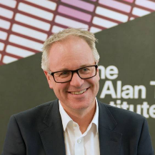
Jason McEwen
Interim Chief Scientist and Mission Director for Fundamental Research

Our Mission

We are the UK’s independent national institute for AI and data science. Our mission is to secure the UK’s national resilience for the age of AI: building the capabilities that help the country understand, withstand and respond to the risks and opportunities created by a rapidly changing world.
We work with the people responsible for the UK’s critical systems — across government, public services, infrastructure, security, health, the economy and the environment — to diagnose the hardest problems they face and turn them into ambitious programmes of research, engineering and deployment. By convening the best minds from academia, industry and government, we build national AI and data science capabilities that can be trusted in the places where they matter most.

This is a mission for people who want their technical work to count. The Institute offers the chance to apply exceptional engineering, scientific and leadership ability to problems of national consequence: making AI useful, safe and dependable in the systems on which the UK relies
The Board

The Alan Turing Institute is establishing a multidisciplinary Scientific Advisory Board of approximately 15 members.

The Board will advise the Chief Scientific Officer and the Board of Trustees, providing independent external challenge on how the Institute pursues its scientific objectives.

The Institute sits at the intersection of scientific discovery, technology, policy and public purpose. Board members will have the opportunity to help shape how AI and data science are directed towards challenges of national consequence.

The role offers the chance to:

Influence the scientific direction of the UK’s national institute for AI and data science.

Work alongside leading thinkers from a wide range of disciplines, sectors and countries.

Help connect frontier research with trusted capabilities that strengthen national resilience.

Contribute to responsible, rigorous and high-impact science in the public interest.

The Board is advisory therefore, will not make executive, governance or portfolio decisions, which remain with the Institute’s Board of Trustees and executive leadership. It will normally hold at least two plenary meetings each year, typically one in person and one virtually. It may also establish time-limited working groups or undertake proportionate ad hoc reviews of programmes, proposals or strategic questions.

Advice will be reached by consensus where possible. Where members hold different views, the range of perspectives will be recorded.



How You Will Make an Impact

As a Board member you will be expected to:

- Advise on the Institute’s scientific direction and long-term strategy.
- Consider the coherence, balance and future readiness of the research portfolio.
- Review the quality, relevance and impact of ongoing and proposed research programmes, including Transformational Resilience Goals.
- Benchmark the Institute’s scientific quality, capabilities, operating model and impact against relevant leading organisations.
- Identify emerging scientific opportunities and threats, and their implications for priorities and capabilities.
- Advise on the Institute’s role across the UK research ecosystem and on national and international partnerships.
- Champion research ethics and integrity, responsible and trustworthy AI, reproducibility and openness.
- Act as an ambassador for the Institute and bring relevant opportunities, partnerships and talent to its attention.
- Bring independent judgement and constructive challenge to the Institute’s most important scientific questions.
- Help ensure that the Institute chooses credible scientific approaches and maintains ambition, quality and distinctiveness.
- Consider whether the overall portfolio is coherent, balanced and ready for future scientific and national needs.
- Assess whether research and engineering outputs are generating meaningful adoption and impact.
- Draw on your expertise and networks to strengthen partnerships across academia, government, industry and the international research community.
- Contribute to focused working groups and reviews where your expertise is particularly relevant.
- Support an open, rigorous and multidisciplinary environment in which differing perspectives improve scientific judgement.

What We Are Looking For

We are looking for people with experience deep enough to advise on scientific strategy at a national scale. This may have been gained inside or outside a conventional academic career.

You will bring recognised expertise in one or more of the following areas:

- AI and machine learning, AI assurance and safety, cyber security, statistics and uncertainty, causal inference and decision science, optimisation, complex systems, simulation and digital twins, human and organisational factors, computational social science, or data infrastructure and engineering.
- Adjacent disciplines such as economics, behavioural and social science, philosophy, organisational science, public policy, law, ethics or the humanities.
- Large-scale applied AI research or engineering, or experience in sectors central to national resilience such as energy, water, transport, telecommunications, health, manufacturing, supply chains, the environment or defence.
- Senior scientific leadership in defence and national security, a national or international research institute, or a research-intensive university.
- Technology translation, innovation, investment or commercialisation.

Alongside your subject expertise, you will bring independence, sound judgement, integrity and the ability to work constructively across disciplines and sectors.

The Scientific Advisory Board is multidisciplinary by design. Its membership will combine internationally recognised scientists, experts from adjacent disciplines, industry leaders and people with experience of national institutions, universities, translation and commercialisation.


Terms and Conditions

This is a voluntary and unremunerated position. Members are committed to approximately five to seven days each year, including preparation, travel, plenary meetings and occasional reviews or working groups. While the Chair will need to commit ten to twelve days each year. Terms are three years long and can be renewed once, with a maximum service of six years.

Members must declare real, potential or perceived conflicts of interest and recuse themselves where appropriate.

Members must protect non-public information shared through Board business. This obligation continues after membership ends.

Some work may involve security-classified, commercially sensitive or partner-sensitive material. Relevant reviews will be undertaken only by appropriately cleared or briefed members and experts.

Members serve in a personal capacity and the Board’s advice is independent and non-binding.

The Chair will be appointed separately and must have the scientific standing to command the confidence of Board members and the wider scientific community, together with experience of advising or leading at a national level.

Members will elect a Deputy Chair from among the Board.

Equality, Diversity and Inclusion

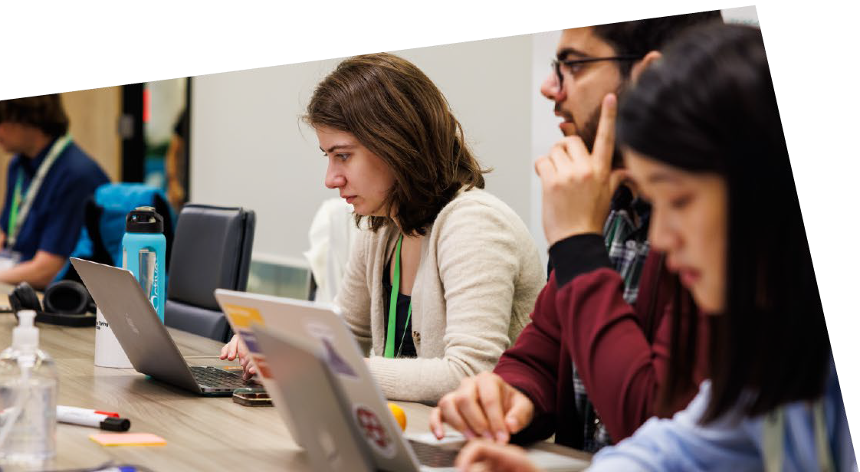
The Institute is seeking breadth across national resilience rather than concentration in any single domain. It also aims to build a Board with a strong international perspective and a diversity of backgrounds, professional routes and viewpoints. If you feel passionately about this role but don’t meet every single requirement, please apply – we recognise that great candidates may bring strengths beyond the criteria listed.



Application Process

The Alan Turing Institute is committed to attracting exceptional and diverse talent and welcomes applications from candidates from all backgrounds.

To apply, candidates should submit:
To express interest, candidates will be asked to provide:
- A current curriculum vitae.
- A short statement explaining their interest, relevant expertise and the contribution they would make to the Scientific Advisory Board.

Applications should be submitted via our candidate portal.
Closing Date: Monday 12 October 2026 at 23:59

Further Information
The full Terms of Reference set out the Board’s remit, composition, governance, meeting arrangements and confidentiality requirements. Candidates invited to progress will receive the final Terms of Reference and any additional information relevant to appointment.

